Tuvalu

INVITATION FOR BID

FOR

MARITIME SURVEILLANCE RADAR SYSTEMS

25th August 2021

CONTENTS

Section 1: Instructions to Bidders 1
1. Goods 1
2. Contents of Bidding Documents 1
3. Documents Comprising the Bid 1
4. Eligibility and Qualifications of Bidders 2
5. Language of Bid 2
6. Currency and Pricing of Bid 2
7. Sealing of Bids 2
8. Submission of Bids 2
9. Bid Evaluation Criteria 2
10. Purchaser’s Rights 2
11. Notification of Award and Signing of Contract 3
12. Publication of Award 3
13. Debriefing 3
14. Complaints 3
15. Fraud and Corruption 3
16. Validity of Bid 4
section 2: conditions of contract 5
section 3: technical specification 7
section 4: price and delivery schedule 8
section 5: declaration on ethical conduct 9
section 6: bid securing declaration 10
section 7: bid submission form 11
section 8: form of contract 12
ATTACHMENT: SHORE BASED RADAR SPECIFICATIONS 14

INVITATION FOR BID

IFB No: OS/TFSP2/21/13

Date: 05/08/2021

- The Tuvalu Fisheries Support Project Phase 2 wishes to enter into a contract for the supply and delivery of marine radar system(s) for fisheries surveillance, funded by its own resources. The Tuvalu Fisheries Department, hereinafter called the Purchaser, now invites quotations from eligible suppliers.
- The contract completion date will be four calendar months after a contract is signed.
- The bidding documents will be available online at mfed.tv or www.tuvalufisheries.tv and will be electronically mailed to interested, eligible and qualified bidders free of charge upon application to the Purchaser by electronic mail at procurement_tv@groups.outlook.com CC:michaelb@tuvalufisheries.tv .
- To be eligible and qualified, a bidder must:
- be a legally registered entity in its country of incorporation;
- not be under notice of debarment by the Government of Tuvalu.
- Documentary evidence of a bidder’s compliance with 4 (a) may be requested.
- Bids must be submitted via email to procurement_tv@groups.outlook.com /CC: michaelb@tuvalufisheries.tv at or before 4pm, 25th August 2021. Late bids will be rejected.
- All bids must be accompanied by a Bid Securing Declaration as described in the bidding documents. Any bid not so accompanied shall be rejected as non-responsive.
- The Purchaser shall award the contract to the bidder that has submitted the lowest evaluated substantially responsive quotation, provided further that the Bidder is determined to be qualified to perform the Contract satisfactorily.
- The Government of Tuvalu will debar a company from bidding and executing any contract for a period of time it shall determine, if at any time it determines that the company has engaged in fraudulent or corrupt practices in competing for or in executing a contract.
- Any party may lodge a complaint at any stage of the procurement process using the procedure described in Part 13 of the Public Procurement Regulations of Tuvalu.

Section 1: Instructions to Bidders

1. Goods

1.1 The Purchaser invites bids for the supply of and delivery of marine radar system(s) for fisheries surveillance, including installation support, as described in these Bidding Documents. The successful bidder will be expected to deliver the Goods within the time allowed under the Conditions of Contract.

1.2 Goods may be sourced from any state or country except those with whom the Government of Tuvalu has officially prohibited commercial relations.

2. Contents of Bidding Documents

2.1 The Bidding Documents comprise the following:

INVITATION FOR BID

SECTION 1: INSTRUCTIONS TO BIDDERS

SECTION 2: CONDITIONS OF CONTRACT

SECTION 3: TECHNICAL SPECIFICATION

SECTION 4: PRICE AND DELIVERY SCHEDULE

SECTION 5: DECLARATION ON ETHICAL CONDUCT

SECTION 6: BID SECURING DECLARATION

SECTION 7: BID SUBMISSION FORM

SECTION 8: FORM OF CONTRACT

ATTACHMENT: SHORE BASED RADAR SPECIFICATIONS

3. Documents Comprising the Bid

3.1 The bid shall comprise the following documents duly completed and signed by the bidder:

Bid Submission Form (Section 7)

Technical Specifications, with Statement of Compliance (Section 3)

Price and Delivery Schedule (Section 4)

Declaration on Ethical Conduct (Section 5)

Bid Securing Declaration (Section 6).

4. Eligibility and Qualifications of Bidders

4.1 To be eligible and qualified, a bidder must:
- not be under notice of debarment by the Government of Tuvalu.

5. Language of Bid

5.1 Bids shall be submitted in the English language including all technical documents supporting the Statement of Compliance.

6. Currency and Pricing of Bid

6.1 All prices shall be quoted in Australian dollars (AUD) for the Goods delivered to the final destination of the Port of Funafuti, Tuvalu. Prices shall be inclusive of all shipping costs, taxes and duties, insurance at full replacement value until acceptance, and any other incidental costs. Bidders should note the current rate of tax and duty is 0%. The prices shall be a fixed price for the duration of the contract.

7. Sealing of Bids

7.1 Due to COVID restrictions delivery of hard copy bids by courier is not currently practical. As a result, bids may be submitted electronically as an email attachment.

8. Submission of Bids

8.1 Bids shall be delivered to the Purchaser no later than 4pm, 25th August,2021 at the email address procurement_tv@groups.outlook.com / CC:michaelb@tuvalufisheries.tv. Any bid received by the Purchaser after the deadline shall be rejected.

9. Bid Evaluation Criteria

9.1 The Purchaser shall award the contract to the bidder that has submitted the lowest evaluated substantially responsive bid, provided further that the Bidder is determined to be qualified to perform the Contract satisfactorily. In evaluating the Bids, the Purchaser will correct any arithmetic errors as follows:

- where there is a discrepancy between amounts in figures and in words, the amount in words shall prevail;

- where there is a discrepancy between the unit rate and the line item total resulting from multiplying the unit rate by the quantity, the unit rate quoted shall prevail;

9.2 If a bidder refuses to accept a correction, its bid shall be rejected and the Bid Securing Declaration executed.

10. Purchaser’s Rights

10.1 The Purchaser reserves the right to accept or reject any bid, and to annul the bidding process at any time prior to issue of the Letter of Award, without incurring any liability to any bidder or any obligation to inform the affected bidders of the grounds for the Purchaser’s decision.

10.2 The Purchaser reserves the right to inspect and audit any and all records of bidders relating both to the preparation of bids and execution of the contract by the winning bidder.

11. Notification of Award and Signing of Contract

11.1 The bidder whose bid has been accepted will be notified of the award by the Purchaser prior to the expiration of the validity period of the bid, by email. The written notification of award will constitute the formation of the Contract. In the event that no notification of award is issued the signature of the Contract by the Purchaser and Bidder shall constitute the formation of the Contract.

12. Publication of Award

12.1 After a contract has been awarded, the Purchaser shall publish the names of the successful and unsuccessful bidders on the Fisheries Department website and public notice board in the Government Offices. The Purchaser shall also notify in writing all participating bidders the name of the successful bidder.

13. Debriefing

13.1 After publication of the award of contract, an unsuccessful bidder has the right to request a debriefing to ascertain why its bid was unsuccessful and the Purchaser shall provide a debriefing. No commercial confidences shall be breached and no detailed information concerning other bids will be disclosed other than the information already read out at bid opening.

14. Complaints

14.1 A complaint may be made by any party at any stage of the procurement process. Complaints received during the bid evaluation process will be reviewed by the Purchaser and a response issued only after the evaluation is completed. Complaints shall be made, and will be received and attended to, in accordance with the procedure defined in Part 13 of the Public Procurement Regulations of Tuvalu.

15. Fraud and Corruption

15.1 The Government of Tuvalu has a policy of zero tolerance of fraud and corruption and shall reject a proposal for award of a contract, or cancel a contract already awarded, if it determines that the bidder or contractor concerned, or any of its personnel, agents, sub-consultants, subcontractors, non-consulting service providers, and suppliers has directly or indirectly engaged in fraud and corruption in securing a contract or implementing the contract. The bidder or contractor concerned shall be liable to debarment from all future Government contracts for a period stated in the Procurement Suspension and Debarment Procedure issued by the Central Procurement Unit.

15.2 All bidders are required to sign the Declaration on Ethical Conduct at Section 5 of these Instructions to Bidders and attach it to their bid. The Declaration will form part of the Contract awarded to the successful bidder.

16. Validity of Bid

16.1 Bids shall remain valid for acceptance for 45 calendar days after the closing date for submission to the Purchaser.

section 2: conditions of contract

1. General Provisions | 1.1 The Supplier confirms that he has examined, read and fully understood all the Contract Documents, comprising:  Bid Submission Form  Price and Delivery Schedule  Form of Contract  Conditions of Contract  Technical Specifications  Declaration on Ethical Conduct  Bid Securing Declaration
 | 1.2 The Contract shall be amended only by written agreement between the Purchaser and the Supplier.
 | 1.3 This Contract shall be subject to the laws of Tuvalu. Every effort shall be made to resolve disputes amicably without referral to third parties. Any dispute that cannot be resolved amicably shall be referred to arbitration under procedures described in the Arbitration Act, 2008 Revised Edition.
2. Purchaser’s and Supplier’s Obligations | 2.1 The Purchaser shall pay the Supplier the Contract price of AUD [Insert amount in words and figures before the contract is signed] for the full delivery of the goods and installation and testing services listed in the Price and Delivery Schedule.
 | 2.2 The Supplier shall supply the goods and installation and testing services listed in the Price and Delivery Schedule at the final destination on or before the delivery date. The goods shall conform to the standards in the Technical Specification and the Supplier shall be responsible for insuring the Goods against all risks of loss and damage from source of manufacture or purchase to the final destination.
 | 2.3 The Purchaser has the right to reduce the payment to the Supplier by 0.1% of the Contract price for each day of delay beyond the contracted completion date. The reduction is up to a maximum of 10%, after which the Purchaser has the right to terminate the contract.
 | 2.4 If Force Majeure makes completion of the contract impossible, the Supplier may ask the Purchaser to be released from the Contract.
 | 2.5 The Supplier guarantees that all goods supplied will be new and unused and carry a warranty for the duration specified in the Bid Submission Form. Throughout the Contract and warranty period, the Supplier agrees to make good, at its own expense, any defect that is due to the quality of materials or workmanship. The Supplier shall submit a warranty certificate issued by the manufacturer of the goods supplied.
 | 2.6 The goods shall be fully insured against loss or damage incidental to manufacture or acquisition, transportation, storage and delivery at the final destination. The all risks insurance shall be obtained by the Supplier in an amount equal to 110% of the value of the goods from the source of manufacture or purchase to the final destination.
3. Risk and Title | 3.1 Risk and title of the goods shall pass to the Purchaser upon delivery to and acceptance of the goods at the final destination in Tuvalu.
4. Payment Provisions | 4.1 [Insert payment schedule]
 | 4.2 The Purchaser shall make payments within 30 days of receipt of the Supplier’s invoices provided that the conditions for payment in Clause 4.1 have been met.
 | 4.3 The Purchaser shall pay interest to the Supplier on any payment that is due and is delayed more than one (1) calendar month beyond the 30 day payment period. The rate of interest shall be 1% per complete calendar month of delay.
5. Termination | 5.1 The Purchaser may at any time terminate the Contract by giving written notice to the Supplier if the Supplier becomes bankrupt or insolvent. In this event, the termination will be without compensation to the Supplier.
 | 5.2 The Purchaser may at any time terminate the Contract in whole or in part for its convenience, by giving written notice to the Supplier. In this event, the goods that are complete and ready for transportation to the final destination within fourteen calendar days after the Supplier’s receipt of the notice of termination shall be accepted by the Purchaser at the Contract terms and prices.

section 3: technical specification

The required goods and their technical specification are contained in the attached document ‘Shore based radar specifications’. Bidders shall address each bullet point in the specification and provide a price in Australian Dollars (AUD). Care should be taken to complete the estimate of shipping costs, to enter the expected date of delivery and to provide the total cost of materials. Bidders may provide brochures or technical literature from the manufacturers showing the detailed specifications of the goods being offered and the manufacturers’ warranty periods.

section 4: price and delivery schedule

(Bidders must complete columns 6 and 7)

1 | 2 | 3 | 4 | 5 | 6 | 7
Item | Description of Goods/Services | Quantity | Unit | Delivery Period  (maximum days from start of contract) | Rate (AUD) | Amount (AUD)  (3 × 6)
1 | Marine radar system 1 for the Funafuti transhipment area, as detailed in the technical specifications | 1 | system | 120
2 | Marine radar system 2 for the Funafuti Conservation Area, as detailed in the technical specifications | 1 | system | 120
 | Total FOB Amount
 | Documentation and Other Charges (if applicable)
 | Freight, Shipping and Insurance to Funafuti (if applicable)
 | Total Cost CIF Funafuti
(Bidders may add extra rows in the table if required)

section 5: declaration on ethical conduct

(The Bidder shall sign and date this form)

Date: _______________

The undersigned, as the authorised representative of the Bidder, confirms that in the preparation of our bid:

- We, our employees, associates, agents, shareholders, partners and consultants, or their relatives or associates:

- have no relationship that could be regarded as a conflict of interest as defined in regulation 71 of the Public Procurement Regulations of Tuvalu; should we become aware of the potential for a conflict of interest, we will advise the Purchaser immediately;

- have not entered into any corrupt or fraudulent practices during the preparation of this bid.

- No unauthorised payments in cash or in kind in connection with this procurement proceeding have been made or will be made by us, our employees, associates, agents, shareholders, partners and consultants, or by their relatives or associates, to any employees, associates, agents, partners or consultants of the Purchaser, or to their relatives and associates.

- We understand that if we are found to be in breach of this Declaration, we shall be debarred from any contracts with the Government of Tuvalu for a period stated in the Procurement Suspension and Debarment Procedure issued by the Central Procurement Unit.

Authorised signature: _____________________

Name and job title: _______________________

Name and address of Bidder: ________________________________

_______________________________________________________

Telephone No: _______________

Fax No: ____________________

E-mail address: ______________

Affix company seal:

section 6: bid securing declaration

(The Bidder shall complete, sign and date this form)

Date: _________________
Name of contract: __________________________
Contract Identification No: __________________
Invitation for Bid No: _______________________

To: (name and address of Purchaser)

We, the undersigned, declare that:

- We understand that this bid must be supported by a Bid Securing Declaration.
- We accept that, if we are in breach of our obligations under the bidding conditions, we shall be debarred from bidding for any contract with the Government of Tuvalu for a period that it may determine, starting from the date when the Purchaser executes this Declaration. The Government of Tuvalu can debar us if we:
- withdraw our Bid during the period of bid validity specified in the Bid Submission Form; or
- do not accept the correction of mathematical errors in accordance with the Instructions to Bidders; or
- fail or refuse to execute the Form of Contract during the period of bid validity, having been notified of the acceptance of our Bid by the Purchaser.
- If we are not named as the successful bidder, we understand that this Bid Securing Declaration shall expire 30 calendar days after the expiry of the validity of our Bid.
- We understand that if we are a Joint Venture, the Bid Securing Declaration must be in the name of the Joint Venture that submits the bid. If the Joint Venture has not been legally constituted at the time of bidding, the Bid Securing Declaration shall be in the names of all future partners in the Joint Venture, as named in our bid.

Signed: _____________________ Print name: ____________________

In the capacity of: ______________________________ (insert job title)

Duly authorized to sign the Bid for and on behalf of: _______________ (name of company or joint venture)

Dated on this ____ day of ________, 20__

section 7: bid submission form

(Reproduce on Bidding Company’s Letter Heading)

To: (insert name of Purchaser – see Section 1)
Offices of the Government of Tuvalu
Vaiaku
Funafuti
Tuvalu

IFB No: OS/____________ (insert number – see Section 1)

Date: ______________

In conformity with the Bidding Documents and in accordance with the Price and Delivery Schedule therein, we offer to supply (insert a brief description of the Goods – add services if specified). The total price of our Bid, including any discounts offered, is (insert AUD amount in words and figures).

This bid and your written acceptance will constitute a binding contract between us until the Form of Contract is signed. We understand that you are not bound to accept the lowest or any bid you receive.

We hereby confirm that this bid will remain valid for 45 calendar days after the deadline for submission of bids.

We note and accept without reservation the Government’s right to audit and inspect any and all records relating both to the preparation of our bid, and if our bid is successful, the execution of the resulting contract.

Signed: _____________________ Print name: ____________________

In the capacity of: ______________________________ (insert job title)

Name and address of bidder: _____________________________________

____________________________________________________________

Affix company seal:

Phone number: __________________

Fax number: ______________________

E-mail address: ____________________

section 8: form of contract

[The Purchaser shall complete this form before signing by both parties]

AGREEMENT

This Agreement is made on the ________day of _______________20__, by and between [insert name and address of Purchaser], hereinafter called the Purchaser, and [insert name and address of Supplier], hereinafter called the Supplier.

Whereas the Purchaser invited bids for [insert brief description of Goods – add services if required] and has accepted a Bid by the Supplier for the supply of those Goods [add “and services” if required] in the sum of [insert Contract Price in Australian Dollars in words and figures] (hereinafter called “the Contract Price”).
Now this Agreement witnesses as follows:
1. In this Agreement, words and expressions shall have the same meanings as are respectively assigned to them in the Conditions of Contract hereafter referred to, and they shall be deemed to form and be read and construed as part of this Agreement.
2. The following documents shall constitute the Contract between the Purchaser and Supplier, and each shall be read and construed as an integral part of the Contract:
- This Contract Agreement
- Conditions of Contract
- Technical Specification
- Priced Delivery Schedule
- Bid Submission Form
- Purchaser’s Notification of Award
- Declaration on Ethical Conduct
3. This Contract shall prevail over all other Contract documents. In the event of any discrepancy or inconsistency within the Contract documents, then the documents shall prevail in the order listed above.
4. In consideration of the payments to be made by the Purchaser to the Supplier as hereinafter mentioned, the Supplier hereby covenants with the Purchaser to execute and complete the Contract in conformity in all respects with the provisions of the Contract.
5. The Purchaser hereby covenants to pay the Supplier in consideration of the execution and completion of the Contract the Contract Price or such other sum as may become payable under the provisions of the Contract at the times and in the manner prescribed by the Contract.
In Witness whereof the parties thereto have caused this Agreement to be executed the day and year first before written.
For and on behalf of the Purchaser

____________________
[signed]

in the capacity of: [insert title or designation and affix official Seal]

in the presence of: [insert name, title and signature of official witness]

For and on behalf of the Supplier

____________________
[signed by authorized representative of the Supplier]

in the capacity of: [insert title or designation and affix official Seal]

in the presence of: [insert name, title and signature of official witness]

ATTACHMENT: SHORE BASED RADAR SPECIFICATIONS

Background

The Tuvalu Fisheries Department (TFD) requests quotation for the supply of two complete shore-based radar installations for the monitoring of inshore maritime activity. Respective requirements and specifications for the two installations are listed below. Suppliers are invited to provide quotations for one or both of the required systems. The TFD prefers acquisition of two similar systems to facilitate training, operation and maintenance activities, however, quotations are to be independent of each other.
The TFD desires delivery of the radar systems as soon as possible and suppliers are urged to determine shipping times carefully. The delivery of System 1 (for the Funafuti transshipment area) is to be prioritised, if necessary.
System 1: Radar for the Funafuti transshipment area
The transshipment area is located within the south-eastern sector of Funafuti lagoon, extending approximately 4 km into the lagoon from the port (Figure 1). There is a risk that local boats, made of wood or fibreglass, may approach the fishing and reefer vessels for trade and bartering purposes, but this is in breach of current customs and quarantine restrictions - this is particularly important during the current COVID pandemic. The main purpose of the radar system is the surveillance of this area to detect this illegal activity.
The TFD building is a possible installation site for the radar system (approximate location -8.50S°, 179.20°E). The radar antenna can be mounted to the roof of the building and any electronic components can be installed in an office below. The apex of the roof is 9 metres above sea level and can hold a maximum weight of 250 kg.
Summary of requirements:
- Radar detection capability: 3-5 m wooden craft with outboard motors.
- Radar detection range: extending to approximately 5 km from the TFD building.
- Integrated camera system capable of recording optical images of the radar detected vessels.
- Integrated automatic identification system (AIS) receiver.
- Data recording and storage: The radar system shall function autonomously and record data for a minimum period of one week.
- Alerting: The system shall be capable of issuing alerts if certain object detections are made.
- Real time detections shall be displayed using geospatial software.
- The system shall be fully operational without an active internet connection, e.g., it shall not rely on cloud services for data storage or processing (internet data transfer with Tuvalu is unreliable and expensive).
- All hardware exposed to the elements is to be made of marine-grade materials as high humidity, salt spray, rain and wind are constant conditions.
- The quoted system should include all components to construct a turn-key system.
- The quote is to include remote support to local technicians installing the system (travel to Tuvalu is likely not possible due to Covid-19 travel restriction).

In addition, providers are to:
- Indicate the expected lifetime of key components of the system and the cost for their replacement;
- Give details of health and safety considerations related to the radar emissions; and
- Provide a date for delivery of the system.
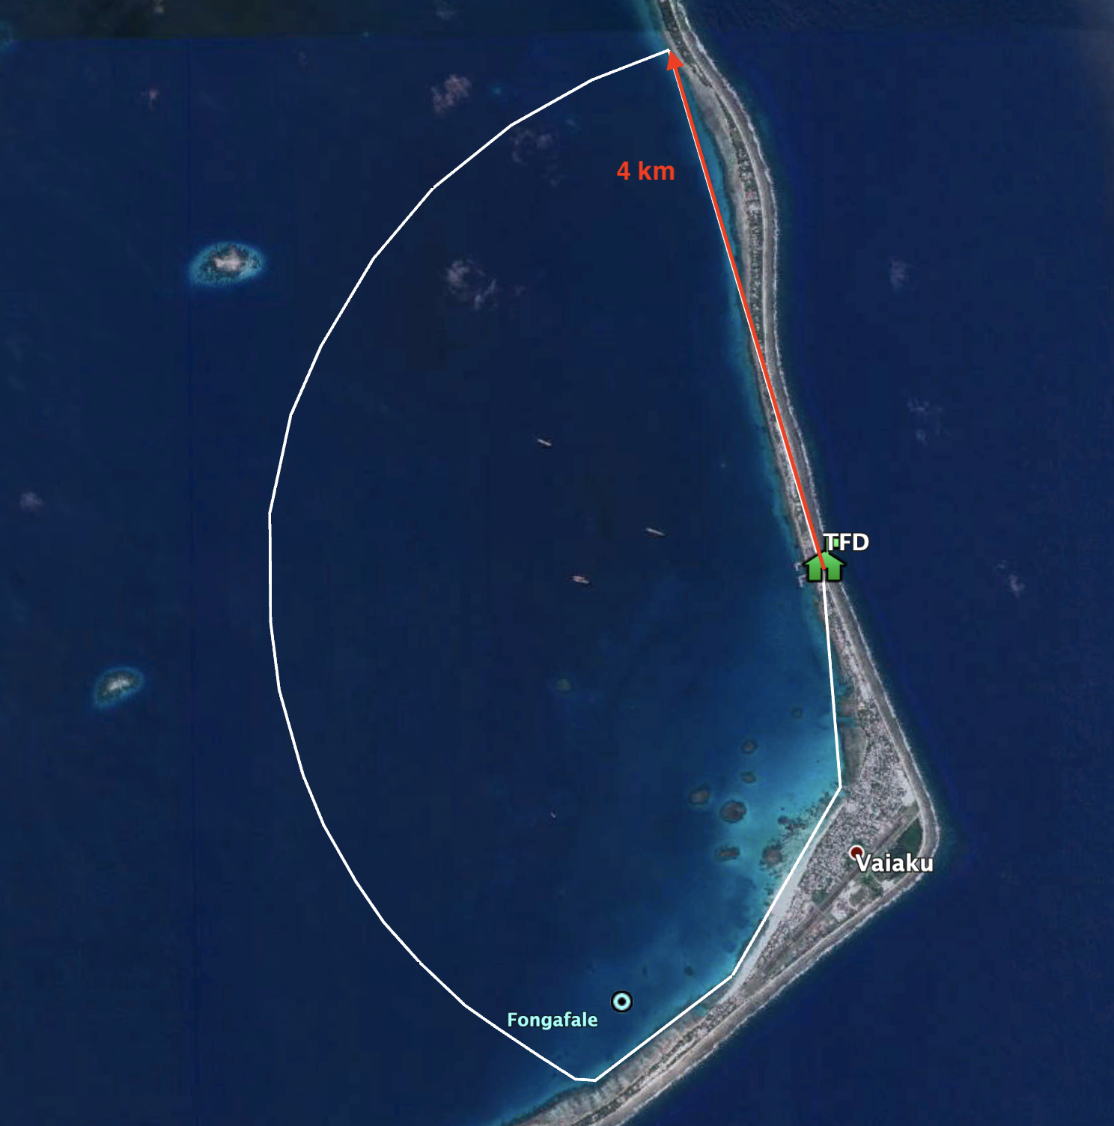
Figure 1: Funafuti transhipment area
System 2: Radar for the Funafuti Conservation Area
The Funafuti Conservation Area (FCA) is located on the western side of the lagoon, approximately 10 to 18 km from the TFD building. The FCA extends from the 20 metre depth contour outside of the lagoon to approximately 2.5 km into its interior (Figure 2). There is no power supply or communications coverage in this part of the atoll.

Illegal fishing in the FCA is carried out by small boats, often at night. Permitted activities such as snorkelling and picnicking also cause small boat traffic in the area. A watchman's hut is to be constructed on one of the islets close to the FCA (approximate location 8.47°S 179.08°E), which may provide a suitable location for the installation of the radar unit. The purpose of the radar system is the surveillance of this area to detect illegal fishing activity.

Summary of requirements:
- Radar detection capability: 3-5 m wooden craft with outboard motors.
- Radar detection range: the maximum extent of the FCA from the proposed hut is 16 km. We seek a compromise between range, mounting on a proposed watch tower which may be as high as 15 metres above sea level, and cost of the unit.
- Integrated camera system capable of recording optical images of the radar detected vessels.
- Data recording and storage: the radar system shall function autonomously and record data for a minimum period of one week.
- Self-contained power supply: the proposed system is to include solar cells and batteries to ensure power-grid independent operation 24/7.
- Event detection: The system shall be capable of recording events if certain object detections are made.
- Data shall be retrievable by manually copying files from the radar system’s data storage to portable storage media.
- The system shall be fully operational without an active internet connection, e.g., it shall not rely on cloud services for data storage or processing (internet data transfer with Tuvalu is unreliable and expensive).
- All hardware exposed to the elements is to be made of marine-grade materials as high humidity, salt spray, rain and wind are constant conditions.
- The quoted system should include all components to construct a turn-key system, including any tower/mast required to mount the antenna.
- The installation is planned for a small watchman’s hut, so the space required should be kept to a minimum and clearly stated in the proposal.
- The quote is to include remote support to local technicians installing the system (travel to Tuvalu is likely not possible due to Covid-19 travel restriction).

In addition, providers are to:
- Indicate the expected lifetime of key components of the system and the cost for their replacement;
- Give details of health and safety considerations related to the radar emissions; and
- Provide a date for delivery of the system.
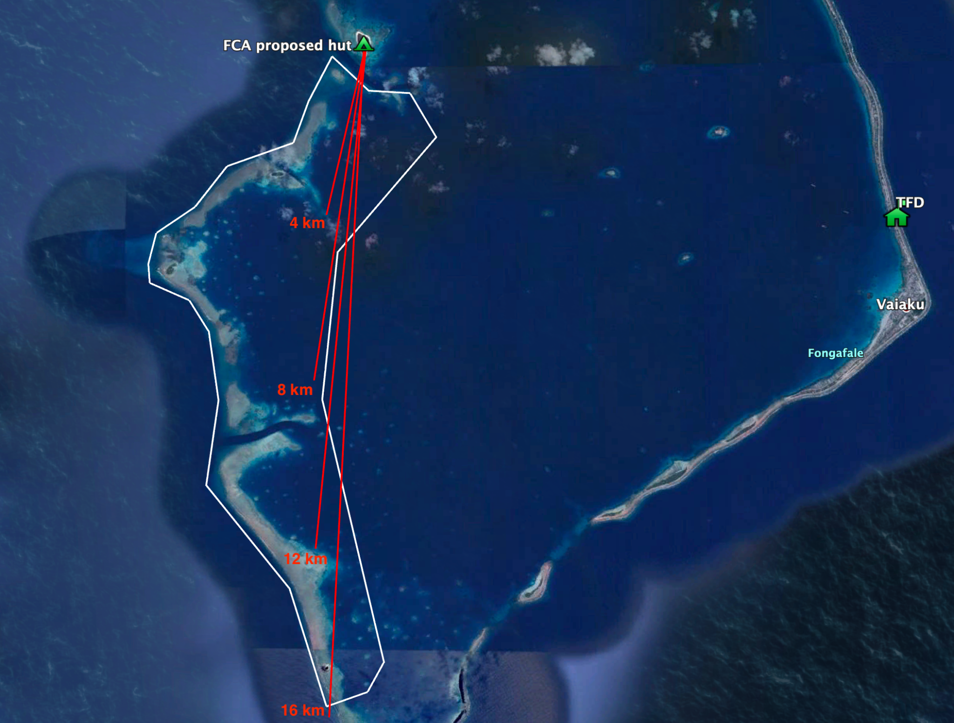
Figure 2: Funafuti Conservation Area

